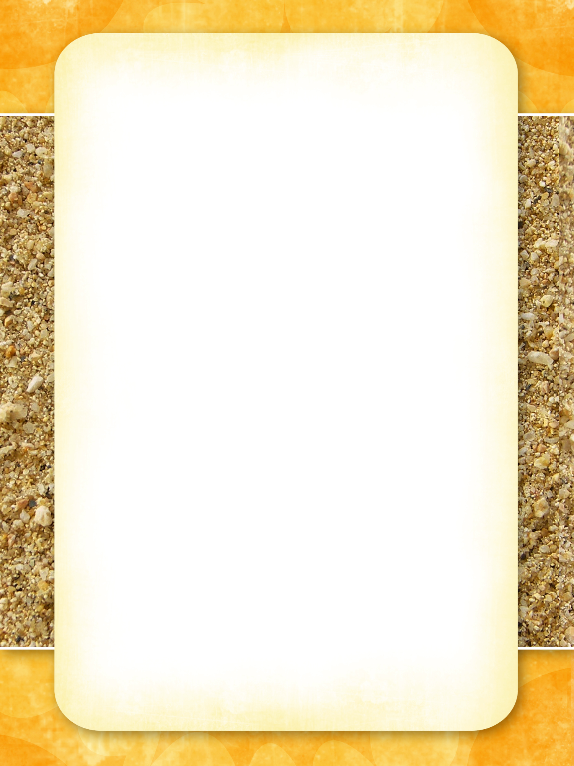

# Reading Activities

**Florida Center for Reading Research**

[**http://www.fcrr.org/curriculum/SCAindex.shtm**](http://www.fcrr.org/curriculum/SCAindex.shtm)

## Phonological Awareness

[**http://www.fcrr.org/curriculum/pdf/GK-1/Archive/PA_Final_Part3.pdf**](http://www.fcrr.org/curriculum/pdf/GK-1/Archive/PA_Final_Part3.pdf)

**Phoneme segmenting and blending - Picture Slide**

[**http://www.fcrr.org/curriculum/PDF/G2-3/2-3PA_2.pdf**](http://www.fcrr.org/curriculum/PDF/G2-3/2-3PA_2.pdf)

## Phonics

## <http://www.fcrr.org/curriculum/pdf/GK-1/Archive/P_Final_Part2.pdf>

**Letter-Sound Correspondence - Letter Stamp Mini-Books**

<http://www.fcrr.org/curriculum/PDF/G2-3/2-3Phonics_1.pdf>

**Letter-Sound Correspondence - Letter Sound Match**

[**http://www.fcrr.org/curriculum/pdf/GK-1/Archive/P_Final_Part4.pdf**](http://www.fcrr.org/curriculum/pdf/GK-1/Archive/P_Final_Part4.pdf)

**Word Study Sorting –**

**Vowel Closed Sort, Letter Cube Blending, Letter Puzzles**

[**http://www.fcrr.org/curriculum/PDF/G2-3/2-3Phonics_3.pdf**](http://www.fcrr.org/curriculum/PDF/G2-3/2-3Phonics_3.pdf)

**Short and Long**

## Fluency

[**http://www.fcrr.org/curriculum/pdf/GK-1/Archive/F_Final.pdf**](http://www.fcrr.org/curriculum/pdf/GK-1/Archive/F_Final.pdf)

**Oral Reading – Repeated Timed Reading, Chunking,**

[**http://www.fcrr.org/curriculum/PDF/G2-3/2-3Fluency_3.pdf**](http://www.fcrr.org/curriculum/PDF/G2-3/2-3Fluency_3.pdf)

**Phrases – Fluent Phrasing, Fast Phrases, Phrase Progression**

## High Frequency Words

[**http://www.fcrr.org/curriculum/pdf/GK-1/Archive/F_Final.pdf**](http://www.fcrr.org/curriculum/pdf/GK-1/Archive/F_Final.pdf)

**High Frequency Words – Pictures and words**

<http://www.fcrr.org/curriculum/PDF/G2-3/2-3Phonics_2.pdf>

**High Frequency Words – Word Concentration**