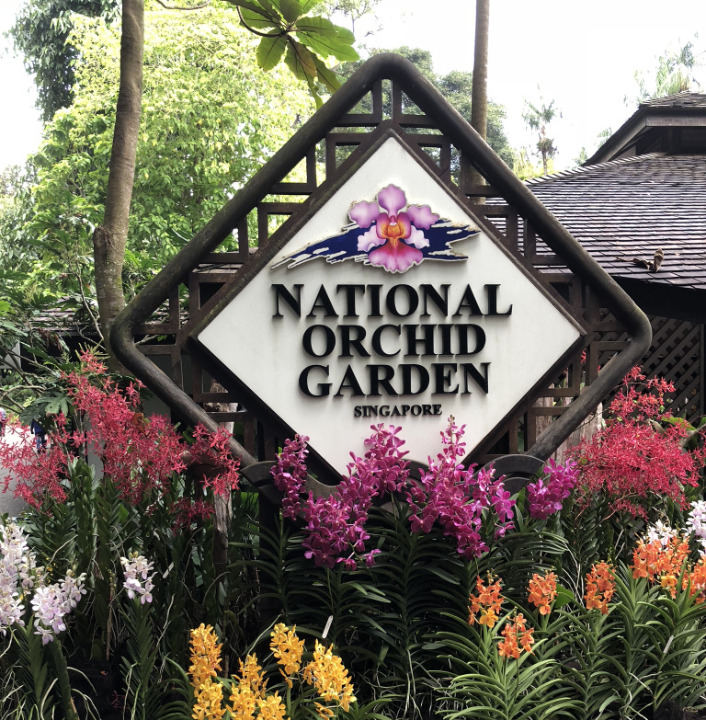  Singapore Botanic Gardens is a 160-year-old tropical garden located at the fringe of Singapore's Orchard Road shopping district. It is one of three gardens, and the only tropical garden, to be honored as a UNESCO World Heritage Site. It was declared the inaugural Garden of the Year, International Garden Tourism Awards in 2012, and received Michelin's three-star rating in 2008.  The National Orchid Garden, within the main gardens, is at the forefront of orchid studies and a pioneer in the cultivation of hybrids, complementing the nation's status as a major exporter of cut orchids, it houses the largest orchid collection of 1,200 species and 2,000 hybrids. | Welcome to MWR  Singapore  Morale, Welfare & Recreation Singapore is located just north of the equator on the sunny, tropical island city-state of Singapore.  Our dedicated mission is providing a quality of life for our military and their families through fitness & sports, child & youth programs, food & beverage services, and a wide availability of recreational activities.  MWR is always looking for feedback on the services they provide. Please take a few minutes to complete a survey by clicking on the appropriate program below and let us know how we’re doing. Any input, positive or negative, is welcome.  Please visit our online survey by SurveyMonkey:  https://www.surveymonkey.com/r/CommunityRecSingapore  MWR COMMUNITY RECREATION cro.mwrsg@gmail.com MWR COMMUNITY RECREATION Address City, ST ZIP Code | MWR COMMUNITY RECREATION  - A Sample of Singapore Gardens
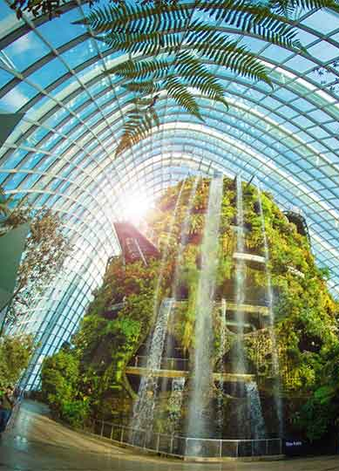  Cloud Forrest Conservatory at Gardens by the Bay  Explore the tropical highlands amidst orchids, pitcher plants and ferns from the cool-moist Tropical Montane region.  Be amazed as you encounter the world's tallest indoor waterfall at 30 meters and descend through the surreal mist-filled Cloud Walk and Treetop Walk. | Gardens by the Bay is a nature park spanning 101 hectares (250 acres) of reclaimed land in the Central Region of Singapore, adjacent to the Marina Reservoir. The park consists of three waterfront gardens: Bay South Garden (in Marina South), Bay East Garden (in Marina East) and Bay Central Garden (in Downtown Core and Kallang).  Bay South, the largest of the three gardens, opened in 2012. With its award-winning cooled conservatories and iconic Supertrees, Bay South has placed Singapore squarely on the international map and is a source of national pride  The Gardens’ calendar - filled with signature festivals, music concerts and movie screenings, sports and community events, and educational workshops and school programs – draw a wide spectrum of visitors to the Gardens. With more than 50 million visitors to date, Gardens by the Bay continues to refresh and refine its offerings, to make the Gardens a place that everyone can enjoy. | 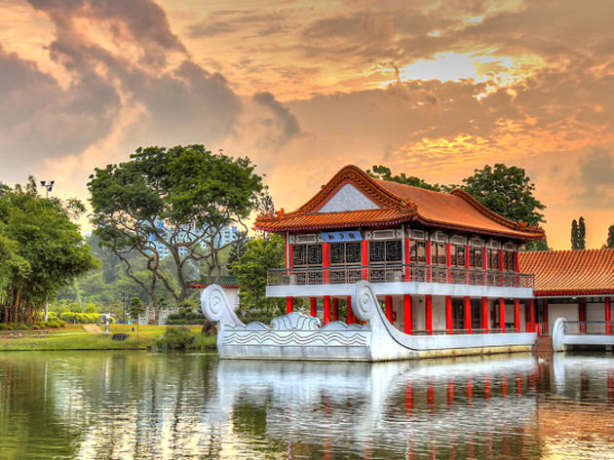  Chinese Gardens, Jurong East  The Chinese Garden’s concept is based on Chinese gardening art and is modeled along the northern Chinese imperial style of architecture and landscaping including a 7 story Pagoda, stone lions, bonsai trees, boat and tea houses, a live turtle and tortoise museum and arched stone bridges which connects to the adjacent Japanese Garden. Along with Japanese Garden, the two gardens are collectively known as the Jurong Gardens.

